Crosby Soccer
2013 Acknowledgements

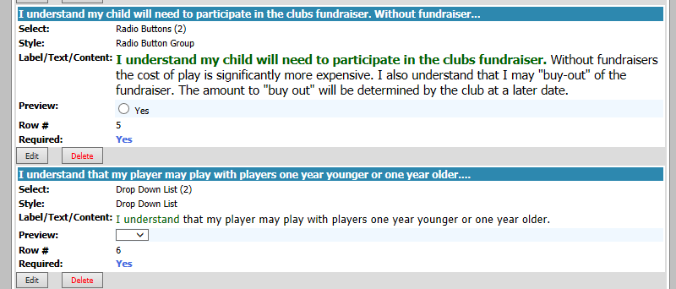
WWW.ELHYSA.ORG

Please initial here____________________

Please initial here____________________

